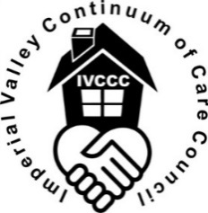

MINUTES
IMPERIAL VALLEY CONTINUUM OF CARE COUNCIL
VULNERABLE POPULATION COMMITTEE MEETING
January 12, 2022
9:00 AM – 10:00 AM
Location: Meeting via Zoom

Name | Organization | Present
Emmanuel Sanchez | Imperial County Dept. Social Services | X
Susan Chasang | Sister Evelyn Mourey Center | X
Mather Mark Edney | IVCCC Executive Board | X
Les Smith | IVCCC Executive Board | X
Araceli Lopez | Imperial County Dept. Social Services | X
Tomas Oliva | City of El Centro | X

- Introductions: Meeting began at approximately 9:00 a.m. All attendees introduced themselves.

- Meeting Calendar: The group agreed to meet on the second Wednesday of each month from 8:00 a.m. to 9:00 a.m., subject to possible time/date changes when found necessary.

- Discussion of proposed/task goals for 2022:
-The committee will work together to update the Imperial Valley Continuum of Care Council (IVCCC) Charter.
-It will review our current website and compare to other Continuums of Care throughout the state to provide more information to the public.
-It will generate a summary of the grants and projects that the AE and other agencies have worked on over the last two years and provide public information.
-It will review and evaluate the data gathered through HMIS, and evaluate performance measures for the different programs with the IVCCC.
-It proposed to increase committee membership & work on community outreach (for the public) as to the mission, history, and accomplishments of IVCCC.

- Action Items:
-Continue with review of IVCCC charter in order to discuss questions and comments.
-Continue reaching out to others in order to increase committee membership.
-Emmanuel to provide a list of CoCs in California so that we can discuss which websites we would like to review.

E. Adjourn:
-Next meeting February 9, 2022, at 8:00 a.m.

